# LAB 3: PROJECT SCHEDULE

* **Purpose:** Make a schedule for your project

# Submission:

* + Work Breakdown Structure
  + Product Backlog and Sprint Backlog

# Work Breakdown Structure

After collecting requirements and defining scope, the next step is creating work breakdown structure (WBS).

There are two common methods of creating WBSs: top-down and bottom-up approaches.

* + Top-down approach: starting with the largest items of the project and break them into subordinate items
  + Bottom-up approach: firstly, identify as many specific tasks related to the project as possible, then aggregate the specific tasks and organize them into summary activities or higher levels in the WBS.

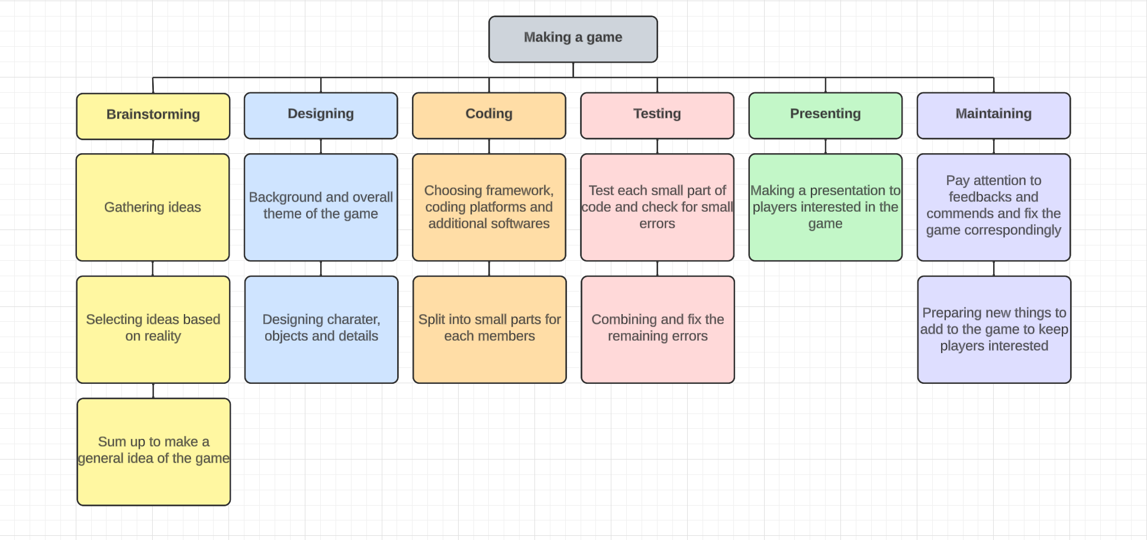

# Product Backlog and Sprint Backlog

* + The product backlog is a list of all the tasks and specifications required to complete the final product.
  + The sprint backlog is smaller in scope and less dynamic than the product backlog. When items are moved from the product backlog to the sprint backlog, they are broken down into more detailed tasks.

**Example:**

## Product Backlog

* + - ***Story name and description –*** This is a brief identifying description of the task to be performed by the backlog item.
    - ***Status:*** the status of backlog items. It can be Open (initial status), In progress and Complete
    - ***Sprint :*** The sprint ID that this story belong to
    - ***Priority:*** The priority of the backlog item. Values for priority are Low, Medium, and High.
    - ***Estimated days:*** estimated duration to finish the task.
    - ***Comments:*** You can add comments here to add key detail or explanation to the story. For larger definitions, use external tools and materials.

| StoryID | Story Name and description | Status | Sprint | Priority | Estimated days | Comments |
| --- | --- | --- | --- | --- | --- | --- |
| 001 | Organize meeting to decide the topic, gather ideas, brainstorm and make final decisions about the general plans | Complete | 1 | Medium | 1 day | Only 8 members, 2 more free slots for new member |
| 002 | Design user interface and draw the entities in the game | In progress | 2 | Low | 5 days |  |
| 003 | Apply and code the functionality off the game | In progress | 3 | High | 30 days |  |
| 004 | Test and fix error of the game | In progress | 4 | High | 15 days |  |
| 005 | Present and introduce the game to everyone | Wait | 5 | Low | 7 days |  |
| 006 | Update and maintain the completed game | Wait | 6 | Low | 3 days |  |

## Sprint Backlog

* + - ***Tasks:*** define all tasks belonging to the sprint.
    - ***Responsibilities***: members in charge

| **Sprint 1: Gathering Ideas** | | |
| --- | --- | --- |
| **Tasks** | **Responsibilities** | **Monday** |
| Organize first meeting to decide the direction and plan for the game | Team | 30 minutes |
| Brainstorm the features and draw outline elements of the game | Team | 30 minutes |

| **Sprint 1: Selecting Ideas Based On Reality** | | |
| --- | --- | --- |
| **Tasks** | **Responsibilities** | **Monday** |
| Divide the team into 2 small groups and discuss about the practicality of each ideas then put them in order | 2 small groups | 15 minutes |
| Compare and choose the ideas based on the priority of the ideas’ practicality | 2 small groups | 15 minutes |

| **Sprint 1: Summing Up Final Ideas** | | |
| --- | --- | --- |
| **Tasks** | **Responsibilities** | **Monday** |
| Review again all the chosen ideas with their reasons | Team | 10 minutes |
| Make final decision and write down the ideas in the report | Leader | 5 minutes |

| **Sprint 2: Design Background And Overall Theme Of The Game** | | | | | | |
| --- | --- | --- | --- | --- | --- | --- |
| **Tasks** | **Responsibilities** | **Tuesday** | **Wednesday** | **Thursday** | **Friday** | **Saturday** |
| Choose the main color and use color wheel to find other colors that suits the main color | UI Designer | 10 minutes |  |  |  |  |
| Draw the background, theme and scenes of the game | UI Designer | 1 hour | 1.5 hours | 1.5 hours | 1.5 hours |  |
| Send finished products, collect feedback from team and edit to release the final results | UI Designer |  |  |  |  | 2.5 hours |

| **Sprint 2: Design Characters, Objects And Details** | | | | | | |
| --- | --- | --- | --- | --- | --- | --- |
| **Tasks** | **Responsibilities** | **Tuesday** | **Wednesday** | **Thursday** | **Friday** | **Saturday** |
| Draw the characters, objects and details | UI Designer | 1 hour | 1.5 hours | 1.5 hours | 1.5 hours |  |
| Send finished products, collect feedback from team and edit to release the final results | UI Designer |  |  |  |  | 2.5 hours |

| **Sprint 3: Choose Framework, Coding Platforms And Additional Softwares** | | |
| --- | --- | --- |
| **Tasks** | **Responsibilities** | **Monday** |
| Discuss about pros and cons of each framework, coding platforms, coding language, applied libraries and softwares that are used in the game | Coding Team | 30 minutes |
| Present the final decision to the whole team | Coding Team | 10 minutes |

| **Sprint 3: Split Into Small Parts For Each Member** | | |
| --- | --- | --- |
| **Tasks** | **Responsibilities** | **Monday** |
| Split and assign to the member accordingly | Coding Team | 10 minutes |
| Answer questions from each member to ensure the understand the task | Coding Team Leader | 15 minutes |

| **Sprint 4: Test Each Small Part Of Code And Check For Small Errors** | | |
| --- | --- | --- |
| **Tasks** | **Responsibilities** | **At Deadline** |
| Test fix the codes in top to bottom order | Coding Team Lead | 20-30 minutes |
| Change small parts of the code like variable names to maintain syncing between  the codes of members | Coding Team | 10 minutes |

| **Sprint 4: Combining And Fix The Remaining Errors** | | |
| --- | --- | --- |
| **Tasks** | **Responsibilities** | **Monday** |
| Add one part of code at a time and fix | Coding Team | 30 minutes |
| Finish combining all the code parts | Coding Team | 1 hour |

| **Sprint 5: Making A Presentation To Players Interested In The Game** | | |
| --- | --- | --- |
| **Tasks** | **Responsibilities** | **Monday** |
| Make visual presentation | Presentation Team | 4-5 hours |
| Prepare the script and practice presenting | Presentation Team | 3-4 hours |
| Prepare additional details of the presentation | Presentation Team | Until the day |

| **Sprint 6: Pay Attention To Feedbacks, Comments And Fix The Game Correspondingly** | | |
| --- | --- | --- |
| **Tasks** | **Responsibilities** | **Monday** |
| Gather feedbacks, comments and cross out the rude or the not supportive ones | Data Analysts | 1 week after  the presentation |
| Analyze the main weakness and ways to improve | Data Analysts | 2 hours |

| **Sprint 6: Preparing New Things To Add Into The Game To Keep Players Who Interested In** | | |
| --- | --- | --- |
| **Tasks** | **Responsibilities** | **Monday** |
| Gather new ideas, plans for the new update | Data Analysts | 2 hours |
| Select the realistic and match the player's expectation | Data Analysts | 1 hour |
| Send to the coding team and make the update | Coding Team | 2 hours |